Employment levels, unemployment
31 March 2021
11:24

Why is this subject important for health and wellbeing?
Unemployment is associated with an increased risk of ill health and mortality. There are relationships between unemployment and poor mental health and suicide, higher self-reported ill health and limiting long term illness and a higher prevalence of risky health behaviours including alcohol use and smoking. Links between unemployment and poor mental health have been explained by the psychosocial effects of unemployment: stigma, isolation and loss of self-worth. People with long term psychiatric problems are less likely to be in employment than those with long-term physical disabilities, despite indications that most people with severe mental illness would like to work. Long-term unemployment has been linked with poorer health satisfaction[1] and increased risk of suicide[2].[1]Gordo, L.R. http://www.tandfonline.com/doi/abs/10.1080/00036840500427692 . Applied Economics,38(20). 2006.[2]Milner, A.M., Page, A. and LaMontagne, A.D. Long-term Unemployment and Suicide: A Systematic Review and Meta-Analysis. PLoS ONE, 8(1): e51333. 2013.
The review "Is work good for your health and wellbeing" (2006) concluded that work was generally good for both physical and mental health and wellbeing.. Access to local employment and good working conditions can influence the health of a community.

Who is affected?

Are some people more at risk than others? Does this vary across areas?

How is it measured?
(Where possible include scale within the county)

What is the direction of travel?

Are there interventions to tackle the problem that are known to be effective? Is anything being done in West Sussex?
Also, what do we know at sub-county level, e.g. Ds&Bs, PCNs

Sources
Also note any gaps in knowledge

Key reports
(PHE reports, key and recent evidence)

Working age on benefits
31 March 2021
11:24

Why is this subject important for health and wellbeing?

Who is affected?

Are some people more at risk than others? Does this vary across areas?

How is it measured?
(Where possible include scale within the county)

What is the direction of travel?

Are there interventions to tackle the problem that are known to be effective? Is anything being done in West Sussex?
Also, what do we know at sub-county level, e.g. Ds&Bs, PCNs

Sources
Also note any gaps in knowledge

Key reports
(PHE reports, key and recent evidence)

Type of work, key employment sectors
31 March 2021
11:24

Why is this subject important for health and wellbeing?

Who is affected?

Are some people more at risk than others? Does this vary across areas?

How is it measured?
(Where possible include scale within the county)

What is the direction of travel?

Are there interventions to tackle the problem that are known to be effective? Is anything being done in West Sussex?
Also, what do we know at sub-county level, e.g. Ds&Bs, PCNs

Sources
Also note any gaps in knowledge

Key reports
(PHE reports, key and recent evidence)

Earnings
31 March 2021
11:24

Why is this subject important for health and wellbeing?

Who is affected?

Are some people more at risk than others? Does this vary across areas?

How is it measured?
(Where possible include scale within the county)

What is the direction of travel?

Are there interventions to tackle the problem that are known to be effective? Is anything being done in West Sussex?
Also, what do we know at sub-county level, e.g. Ds&Bs, PCNs

Sources
Also note any gaps in knowledge

Key reports
(PHE reports, key and recent evidence)

Impact of COVID
Any very measurable impacts?
Use of food banks - significant increase in use during covid
Homelessness - access to housing/temorary housing
Smoking - especially self-reported quits and access to quit services
31 March 2021
11:24

Why is this subject important for health and wellbeing?

Who is affected?

Are some people more at risk than others? Does this vary across areas?

How is it measured?
(Where possible include scale within the county)

What is the direction of travel?

Are there interventions to tackle the problem that are known to be effective? Is anything being done in West Sussex?
Also, what do we know at sub-county level, e.g. Ds&Bs, PCNs

Sources
Also note any gaps in knowledge

Key reports
(PHE reports, key and recent evidence)

Health and social care workforce
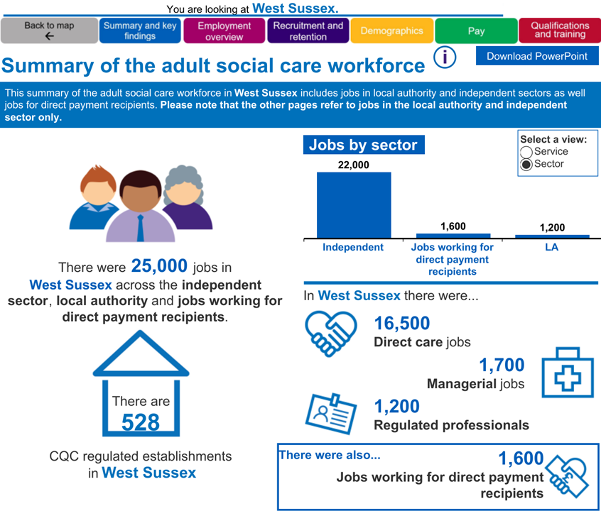
31 March 2021
11:25

Why is this subject important for health and wellbeing?
Indicates availability of resources
See files for overview from skillsforcare (snapshot to the right)

Who is affected?
Workers and those in need of health services

Are some people more at risk than others? Does this vary across areas?

How is it measured?
(Where possible include scale within the county)

What is the direction of travel?
Size of workforce/economic contribution, CQC establishments, Employment overview (zero hours contract or FTW), recruitment and retention, demographics, pay and qualifications.
County appears to be lowest level data but can also get GP specific workers (shared workers eg nurses are not counted twice) https://digital.nhs.uk/data-and-information/data-tools-and-services/data-services/general-practice-data-hub/workforce

Are there interventions to tackle the problem that are known to be effective? Is anything being done in West Sussex?
Also, what do we know at sub-county level, e.g. Ds&Bs, PCNs

Sources
Also note any gaps in knowledge
https://digital.nhs.uk/data-and-information/data-tools-and-services/data-services/general-practice-data-hub/workforce
https://www.skillsforcare.org.uk/adult-social-care-workforce-data/Workforce-intelligence/publications/local-information/My-local-authority-area.aspx
Power BI

Key reports
(PHE reports, key and recent evidence)

Essential workers
31 March 2021
11:25

Why is this subject important for health and wellbeing?

Who is affected?

Are some people more at risk than others? Does this vary across areas?

How is it measured?
(Where possible include scale within the county)

What is the direction of travel?

Are there interventions to tackle the problem that are known to be effective? Is anything being done in West Sussex?
Also, what do we know at sub-county level, e.g. Ds&Bs, PCNs

Sources
Also note any gaps in knowledge

Key reports
(PHE reports, key and recent evidence)

Unpaid carers, carers allowance
31 March 2021
11:25

Why is this subject important for health and wellbeing?
According to Carers UK, more than 1 in 8 adults in the UK care for a family member or friend. This care is crucial to meet the needs of the growing population of older people and people with long-term conditions or disabilities, but the vital role often goes unrecognised.

Who is affected?

Paid/unpaid carers and their charges

Are some people more at risk than others? Does this vary across areas?

How is it measured?
(Where possible include scale within the county)

What is the direction of travel?
The current number of unpaid carers in West Sussex can be estimated
by applying the percentage of unpaid carers in the population, as
recorded in the most recent census (2011), to the latest population

+14% O65 have begun providing care since the start of COVID

Are there interventions to tackle the problem that are known to be effective? Is anything being done in West Sussex?
Also, what do we know at sub-county level, e.g. Ds&Bs, PCNs

Sources
Also note any gaps in knowledge
https://www.carersuk.org/news-and-campaigns/press-releases/facts-and-figures
https://www.carersuk.org/images/CarersWeek2020/CW_2020_Research_Report_WEB.pdf

Key reports
(PHE reports, key and recent evidence)

Poverty in working age population
31 March 2021
11:25

Why is this subject important for health and wellbeing?

Who is affected?

Are some people more at risk than others? Does this vary across areas?

How is it measured?
(Where possible include scale within the county)

What is the direction of travel?

Are there interventions to tackle the problem that are known to be effective? Is anything being done in West Sussex?
Also, what do we know at sub-county level, e.g. Ds&Bs, PCNs

Sources
Also note any gaps in knowledge

Key reports
(PHE reports, key and recent evidence)

Use of food banks
31 March 2021
11:25

Why is this subject important for health and wellbeing?
The charitable food system is vital for food access for vulnerable people in nearly every community. The vast majority of individuals and families accessing food pantries and other charitable food programs are food insecure, meaning that there is a limited or uncertain availability of nutritionally adequate foods. Food insecurity is related to poor nutrition and many other negative health outcomes. Some of these health outcomes include poor physical, cognitive and socioemotional development among children and chronic health conditions, including diabetes, hypertension, and obesity, among adults.
Food poverty is a legitimate area of concern for PHE, entrusted with protecting the nation’s health and addressing inequalities. Healthy diets are not just a basic human need. They are also vital for public health. We know that unhealthy diets are a major factor behind this country’s burden of chronic disease. An unhealthy diet is not just one of excess, some people may also struggle to buy the food they want or need.

Who is affected?
Vulnerable people, impoverished communities

Are some people more at risk than others? Does this vary across areas?

How is it measured?
(Where possible include scale within the county)

What is the direction of travel?
Number of accessing food banks
Huge uptake for COVID

Are there interventions to tackle the problem that are known to be effective? Is anything being done in West Sussex?
Also, what do we know at sub-county level, e.g. Ds&Bs, PCNs
https://www.trusselltrust.org/what-we-do/ - charity side
(local interventions????)
Temporary £20 uplift for universal credit

Sources
Also note any gaps in knowledge
https://www.trusselltrust.org/news-and-blog/latest-stats/end-year-stats/
https://www.statista.com/statistics/382695/uk-foodbank-users/#:~:text=Number%20of%20people%20using%20food%20banks%20in%20the%20UK%202008%2D2021&text=In%202020%2F21%20approximately%202.5,26%20thousand%20in%202008%2F09.

Key reports
(PHE reports, key and recent evidence)

Homelessness

PHOF

Households owed a duty under the Homelessness Reduction Act (B15a): WS rate for 2019/2020 is lower than England (12.3 per 1,000), at 8.5 per 1,000, and third lowest of CIPFA neighbours.

At D&B level, all lower than England, except Crawley, at 14.8 per 1,000.

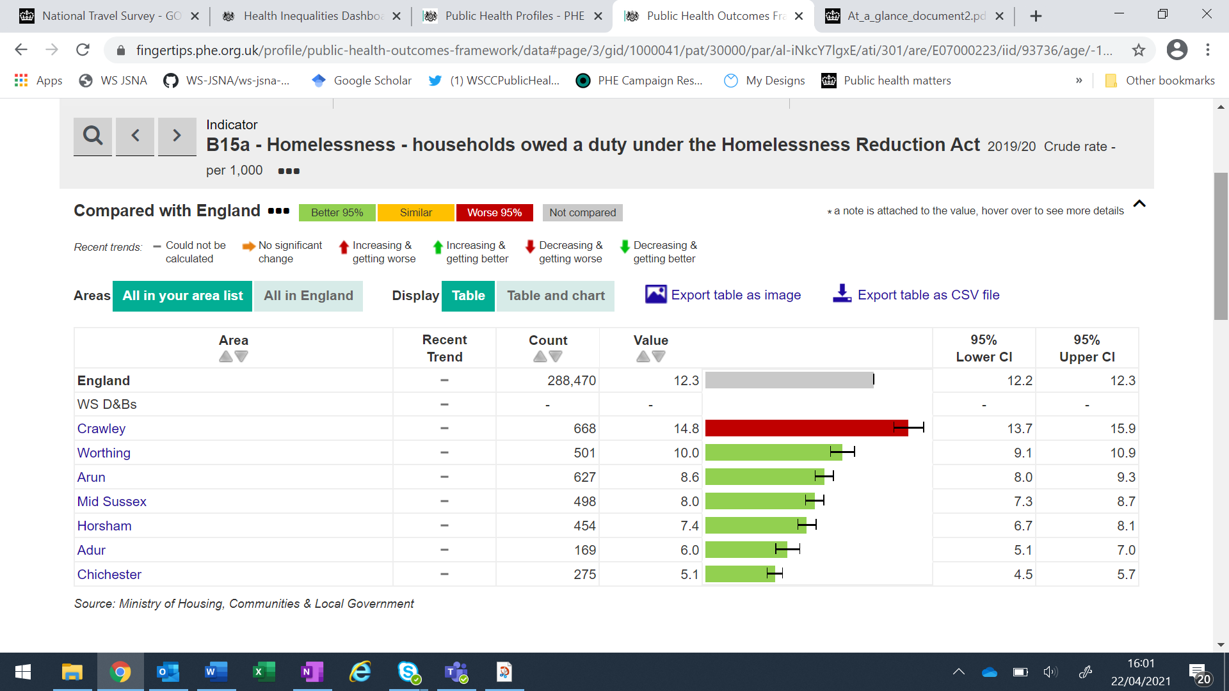

Homelessness - households with dependent children owed a duty under the Homelessness Reduction Act: The WS rate for 2019/2020 is 12.3 per 1,000 (England 14.9 per 1,000) and in the lower half of CIPFA neighbours.

Households in temporary accommodation (B15c): The rate in WS for 2019/2020 is below that of England (2.1 per 1,000 vs. 3.8 per 1,000), but is in the top three of CIPFA neighbours (third after East Sussex).

At D&B level, Crawley (3.9 per 1,000) is again higher than the other D&Bs and similar to England.
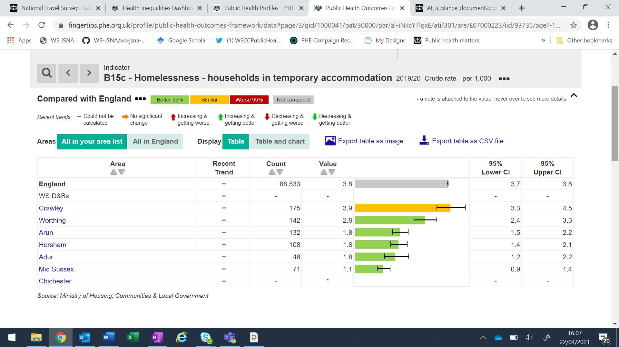
22 April 2021
15:51

Why is this subject important for health and wellbeing?
Physical, mental and substance misuse issues remain prevalent among the homeless population and at levels that are much higher than those experienced by the general population.

Who is affected?

Are some people more at risk than others? Does this vary across areas?

How is it measured?
(Where possible include scale within the county)

What is the direction of travel?

Are there interventions to tackle the problem that are known to be effective? Is anything being done in West Sussex?
Also, what do we know at sub-county level, e.g. Ds&Bs, PCNs
PROJECT WITH DANIELLE ET AL

Sources
Also note any gaps in knowledge

https://www.homeless.org.uk/sites/default/files/site-attachments/The%20unhealthy%20state%20of%20homelessness%20FINAL.pdf

Key reports
(PHE reports, key and recent evidence)

Sexual health
31 March 2021
11:26

Why is this subject important for health and wellbeing?
Having good sexual health is a crucial part of physical and emotional health and wellbeing. Furthermore it is central to the development of the most empowering and important relationships in peoples’ lives. The ability to plan when to have children is also critical to the economic development of young families.

Who is affected?

Sexually active

Are some people more at risk than others? Does this vary across areas?
Young people, MSM, Black and Ethnic Minority (poorly recorded), people who misuse drugs and alcohol, homeless, CLA, HIV+, people with learning disabilities

Women/people with uteruses access to contraceptives and pain relief offered
Period poverty

How is it measured?
(Where possible include scale within the county)

What is the direction of travel?
STIs, conceptions, abortions, use of sexual health services

All STI diagnoses - 4457 rate per 100,000 in 2019 (down from 2018) for WS total - able to get to District Level

No update for most of the previous JSNA data

Are there interventions to tackle the problem that are known to be effective? Is anything being done in West Sussex?
Also, what do we know at sub-county level, e.g. Ds&Bs, PCNs
Sexual health services (service operates hubs out of Chichester, Worthing and Crawley) (MAP?)
Chichester Sexual Health Clinic
St Richards Hospital
Chichester
PO19 6SE

Walk in clinics around the county (MAP?)
Psychosexual services (sexual trauma/pain, dysfunction, function related to ill health/disability)
Contraceptive services
Emergency contraception (MAP EXISTS)
Termination of pregnancy (Brighton and Bognor)
Outreach - practical demonstrations (eg condoms), LGBT services etc

Sources
Also note any gaps in knowledge
https://jsna.westsussex.gov.uk/updates/sexual-health-needs-assessment-2019/#:~:text=The%20Public%20Health%20and%20Social,West%20Sussex%20are%20sexually%20active.

https://fingertips.phe.org.uk/profile/SEXUALHEALTH

Key reports
(PHE reports, key and recent evidence)
https://jsna.westsussex.gov.uk/assets/living-well/West-Sussex-Sexual-Health-Needs-Assessment-2019.pdf

Reproductive health
31 March 2021
11:26

Why is this subject important for health and wellbeing?

Who is affected?

Are some people more at risk than others? Does this vary across areas?

How is it measured?
(Where possible include scale within the county)

What is the direction of travel?

Are there interventions to tackle the problem that are known to be effective? Is anything being done in West Sussex?
Also, what do we know at sub-county level, e.g. Ds&Bs, PCNs

Sources
Also note any gaps in knowledge

Key reports
(PHE reports, key and recent evidence)

Substance Misuse - focus on Rob's Substance Misuse Needs Assessment
31 March 2021
11:26

Why is this subject important for health and wellbeing?

Who is affected?

Are some people more at risk than others? Does this vary across areas?

How is it measured?
(Where possible include scale within the county)

What is the direction of travel?

Are there interventions to tackle the problem that are known to be effective? Is anything being done in West Sussex?
Also, what do we know at sub-county level, e.g. Ds&Bs, PCNs

Sources
Also note any gaps in knowledge
https://digital.nhs.uk/data-and-information/areas-of-interest/public-health/what-about-youth-study

https://digital.nhs.uk/data-and-information/publications/statistical/health-and-wellbeing-of-15-year-olds-in-england/main-findings---2014

Key reports
(PHE reports, key and recent evidence)

Smoking
31 March 2021
11:26

Why is this subject important for health and wellbeing?
Respiratory disease is one of the top causes of death in England in under 75s and smoking is the major cause of chronic obstructive pulmonary disease (COPD), one of the major respiratory diseases. This indicator will focus public health attention on the prevention of smoking and other environmental factors that contribute to people getting respiratory disease. The inclusion of this indicator (alongside other indicators in the Public Health and NHS Outcomes Frameworks) reinforces the Government's commitment to reducing avoidable deaths through public health policy and interventions and sends out a clear signal that prevention of respiratory disease is just as important as treatment.

Who is affected?
1st, 2nd, 3rd hand smokers
Health services

Are some people more at risk than others? Does this vary across areas?
To start smoking - those with parents or siblings who smoke are 3 times more likely to start smoking than those without
Those who start smoking at the youngest ages are more likely to smoke heavily and find it harder to give up.
Heavy smokers are at the greatest risk of developing smoking related diseases.

How is it measured?
(Where possible include scale within the county)

What is the direction of travel?
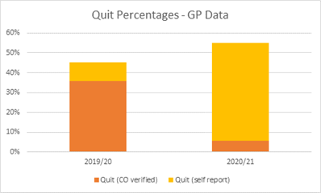
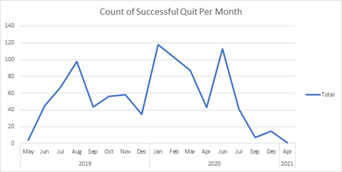
High quit success rates in under 18s (N.B. low numbers)
60+ quit rate was lowest in Mid Sussex
Very low quit success rate in 18-34 year olds in Crawley
No successful quits in 35-44 year olds in Arun

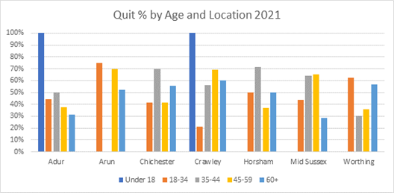

Are there interventions to tackle the problem that are known to be effective? Is anything being done in West Sussex?
Also, what do we know at sub-county level, e.g. Ds&Bs, PCNs
Pharmacotherapy support - NRTs, Champix, Zyban
Unlicensed NCPs (e-cig, vape etc)

• Patients who smoke experience worse clinical outcomes than people who have never smoked. Quitting smoking at the time of, or soon after, diagnosis improves disease outcomes
• Smokers with lung cancer automatically referred into a telephone-based smoking cessation service demonstrated a near doubling of survival
• Stop Smoking Services as a part of comprehensive tobacco control strategy across the county
• Smoking cessation reduces the rate of progression of COPD
• Smoking cessation after stroke or transient ischemic attack reduced the 5-year risk of stroke, myocardial infarction or death to 15.7% (from 22.6% among those who continued to smoke)

Sources
Also note any gaps in knowledge

Key reports
(PHE reports, key and recent evidence)

Physical activity and inactivity
31 March 2021
11:26

Why is this subject important for health and wellbeing?

Who is affected?

Are some people more at risk than others? Does this vary across areas?

How is it measured?
(Where possible include scale within the county)

What is the direction of travel?

Are there interventions to tackle the problem that are known to be effective? Is anything being done in West Sussex?
Also, what do we know at sub-county level, e.g. Ds&Bs, PCNs

Sources
Also note any gaps in knowledge

Key reports
(PHE reports, key and recent evidence)

Obesity
31 March 2021
11:26

Why is this subject important for health and wellbeing?

Who is affected?

Are some people more at risk than others? Does this vary across areas?

How is it measured?
(Where possible include scale within the county)

What is the direction of travel?
Percentage of adults (aged 18+) classified as overweight or obese
AreaName | Time period | Value
England | 2019/20 | 62.79654
South East region | 2019/20 | 61.48302
West Sussex | 2019/20 | 61.6762

Are there interventions to tackle the problem that are known to be effective? Is anything being done in West Sussex?
Also, what do we know at sub-county level, e.g. Ds&Bs, PCNs

Sources
Also note any gaps in knowledge

Key reports
(PHE reports, key and recent evidence)

Gambling
31 March 2021
11:26

Why is this subject important for health and wellbeing?

Who is affected?

Are some people more at risk than others? Does this vary across areas?

How is it measured?
(Where possible include scale within the county)

What is the direction of travel?

Are there interventions to tackle the problem that are known to be effective? Is anything being done in West Sussex?
Also, what do we know at sub-county level, e.g. Ds&Bs, PCNs

Sources
Also note any gaps in knowledge

Key reports
(PHE reports, key and recent evidence)

Screening programmes - cancer
31 March 2021
11:26

Why is this subject important for health and wellbeing?

**effect of COVID-19 on provision and take-up

Who is affected?

Are some people more at risk than others? Does this vary across areas?

How is it measured?
(Where possible include scale within the county)

What is the direction of travel?

Are there interventions to tackle the problem that are known to be effective? Is anything being done in West Sussex?
Also, what do we know at sub-county level, e.g. Ds&Bs, PCNs

Sources
Also note any gaps in knowledge

Key reports
(PHE reports, key and recent evidence)

Screening programmes - Non-cancer (AAA, Diabetic retinopathy)
31 March 2021
11:27

Why is this subject important for health and wellbeing?

**effect of COVID-19 on provision and take-up

Who is affected?

Are some people more at risk than others? Does this vary across areas?

How is it measured?
(Where possible include scale within the county)

What is the direction of travel?

Are there interventions to tackle the problem that are known to be effective? Is anything being done in West Sussex?
Also, what do we know at sub-county level, e.g. Ds&Bs, PCNs

Sources
Also note any gaps in knowledge

Key reports
(PHE reports, key and recent evidence)

Health checks
31 March 2021
11:27

Why is this subject important for health and wellbeing?

**effect of COVID-19 on provision and take-up

Who is affected?

Are some people more at risk than others? Does this vary across areas?

How is it measured?
(Where possible include scale within the county)

What is the direction of travel?

Are there interventions to tackle the problem that are known to be effective? Is anything being done in West Sussex?
Also, what do we know at sub-county level, e.g. Ds&Bs, PCNs

Sources
Also note any gaps in knowledge

Key reports
(PHE reports, key and recent evidence)

Health checks - LD
31 March 2021
11:27

Why is this subject important for health and wellbeing?

Who is affected?

Are some people more at risk than others? Does this vary across areas?

How is it measured?
(Where possible include scale within the county)

What is the direction of travel?

Are there interventions to tackle the problem that are known to be effective? Is anything being done in West Sussex?
Also, what do we know at sub-county level, e.g. Ds&Bs, PCNs

Sources
Also note any gaps in knowledge

Key reports
(PHE reports, key and recent evidence)

Health checks - SMI
31 March 2021
11:27

Why is this subject important for health and wellbeing?

Who is affected?

Are some people more at risk than others? Does this vary across areas?

How is it measured?
(Where possible include scale within the county)

What is the direction of travel?

Are there interventions to tackle the problem that are known to be effective? Is anything being done in West Sussex?
Also, what do we know at sub-county level, e.g. Ds&Bs, PCNs

Sources
Also note any gaps in knowledge

Key reports
(PHE reports, key and recent evidence)

Specific conditions - neurological conditions including ABI
31 March 2021
11:28

Why is this subject important for health and wellbeing?

Who is affected?

Are some people more at risk than others? Does this vary across areas?

How is it measured?
(Where possible include scale within the county)

What is the direction of travel?

Are there interventions to tackle the problem that are known to be effective? Is anything being done in West Sussex?
Also, what do we know at sub-county level, e.g. Ds&Bs, PCNs

Sources
Also note any gaps in knowledge

Key reports
(PHE reports, key and recent evidence)

Specific conditions - diabetes
31 March 2021
11:28

Why is this subject important for health and wellbeing?

Who is affected?

Are some people more at risk than others? Does this vary across areas?

How is it measured?
(Where possible include scale within the county)

What is the direction of travel?
QOF 2019/20 fingertips

Are there interventions to tackle the problem that are known to be effective? Is anything being done in West Sussex?
Also, what do we know at sub-county level, e.g. Ds&Bs, PCNs

Sources
Also note any gaps in knowledge

Key reports
(PHE reports, key and recent evidence)

Specific conditions - learning disability
31 March 2021
11:28

Why is this subject important for health and wellbeing?

Who is affected?

Are some people more at risk than others? Does this vary across areas?

How is it measured?
(Where possible include scale within the county)

What is the direction of travel?

Are there interventions to tackle the problem that are known to be effective? Is anything being done in West Sussex?
Also, what do we know at sub-county level, e.g. Ds&Bs, PCNs

Sources
Also note any gaps in knowledge

Key reports
(PHE reports, key and recent evidence)

Measuring wellbeing
31 March 2021
11:28

Why is this subject important for health and wellbeing?

Who is affected?

Are some people more at risk than others? Does this vary across areas?

How is it measured?
(Where possible include scale within the county)

What is the direction of travel?

Are there interventions to tackle the problem that are known to be effective? Is anything being done in West Sussex?
Also, what do we know at sub-county level, e.g. Ds&Bs, PCNs

Sources
Also note any gaps in knowledge

Key reports
(PHE reports, key and recent evidence)

Mental Health - Wellbeing (ONS)
31 March 2021
11:28

Why is this subject important for health and wellbeing?

Who is affected?

Are some people more at risk than others? Does this vary across areas?

How is it measured?
(Where possible include scale within the county)

What is the direction of travel?

Are there interventions to tackle the problem that are known to be effective? Is anything being done in West Sussex?
Also, what do we know at sub-county level, e.g. Ds&Bs, PCNs

Sources
Also note any gaps in knowledge

Key reports
(PHE reports, key and recent evidence)

Mental Health - general population and SMI recorded
31 March 2021
11:29

Why is this subject important for health and wellbeing?

Who is affected?

Are some people more at risk than others? Does this vary across areas?

How is it measured?
(Where possible include scale within the county)

What is the direction of travel?

Are there interventions to tackle the problem that are known to be effective? Is anything being done in West Sussex?
Also, what do we know at sub-county level, e.g. Ds&Bs, PCNs

Sources
Also note any gaps in knowledge

Key reports
(PHE reports, key and recent evidence)

Suicide and self-harm
31 March 2021
11:29

Why is this subject important for health and wellbeing?

Who is affected?

Are some people more at risk than others? Does this vary across areas?

How is it measured?
(Where possible include scale within the county)

What is the direction of travel?

Are there interventions to tackle the problem that are known to be effective? Is anything being done in West Sussex?
Also, what do we know at sub-county level, e.g. Ds&Bs, PCNs

Sources
Also note any gaps in knowledge

Key reports
(PHE reports, key and recent evidence)

Mental health and COVID
31 March 2021
11:29

Why is this subject important for health and wellbeing?

Who is affected?

Are some people more at risk than others? Does this vary across areas?

How is it measured?
(Where possible include scale within the county)

What is the direction of travel?

Are there interventions to tackle the problem that are known to be effective? Is anything being done in West Sussex?
Also, what do we know at sub-county level, e.g. Ds&Bs, PCNs

Sources
Also note any gaps in knowledge

Key reports
(PHE reports, key and recent evidence)

Premature mortality (including causes)
31 March 2021
11:30

Why is this subject important for health and wellbeing?

Who is affected?

Are some people more at risk than others? Does this vary across areas?

How is it measured?
(Where possible include scale within the county)

What is the direction of travel?

Are there interventions to tackle the problem that are known to be effective? Is anything being done in West Sussex?
Also, what do we know at sub-county level, e.g. Ds&Bs, PCNs

Sources
Also note any gaps in knowledge

Key reports
(PHE reports, key and recent evidence)

Overall burden of disease GBD
31 March 2021
11:30

Why is this subject important for health and wellbeing?

Who is affected?

Are some people more at risk than others? Does this vary across areas?

How is it measured?
(Where possible include scale within the county)

What is the direction of travel?

Are there interventions to tackle the problem that are known to be effective? Is anything being done in West Sussex?
Also, what do we know at sub-county level, e.g. Ds&Bs, PCNs

Sources
Also note any gaps in knowledge

Key reports
(PHE reports, key and recent evidence)

Specific conditions - stroke
31 March 2021
11:30

Why is this subject important for health and wellbeing?

Who is affected?

Are some people more at risk than others? Does this vary across areas?

How is it measured?
(Where possible include scale within the county)

What is the direction of travel?

Are there interventions to tackle the problem that are known to be effective? Is anything being done in West Sussex?
Also, what do we know at sub-county level, e.g. Ds&Bs, PCNs

Sources
Also note any gaps in knowledge

Key reports
(PHE reports, key and recent evidence)

Specific conditions - CHD
31 March 2021
11:31
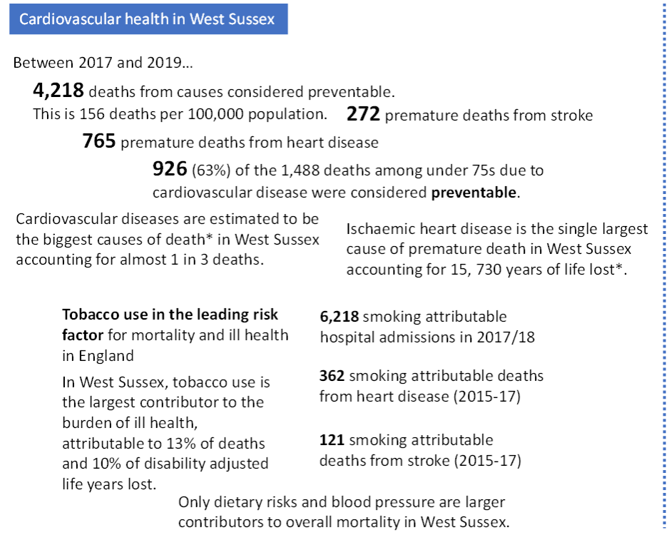

Why is this subject important for health and wellbeing?

Who is affected?

Are some people more at risk than others? Does this vary across areas?

How is it measured?
(Where possible include scale within the county)

What is the direction of travel?

Are there interventions to tackle the problem that are known to be effective? Is anything being done in West Sussex?
Also, what do we know at sub-county level, e.g. Ds&Bs, PCNs

Sources
Also note any gaps in knowledge

Key reports
(PHE reports, key and recent evidence)

Specific conditions - respiratory disease
31 March 2021
11:31

Why is this subject important for health and wellbeing?

Who is affected?

Are some people more at risk than others? Does this vary across areas?

How is it measured?
(Where possible include scale within the county)

What is the direction of travel?

Are there interventions to tackle the problem that are known to be effective? Is anything being done in West Sussex?
Also, what do we know at sub-county level, e.g. Ds&Bs, PCNs

Sources
Also note any gaps in knowledge

Key reports
(PHE reports, key and recent evidence)

Specific conditions - HIV
31 March 2021
11:31

Why is this subject important for health and wellbeing?

Who is affected?

Are some people more at risk than others? Does this vary across areas?

How is it measured?
(Where possible include scale within the county)

What is the direction of travel?

Are there interventions to tackle the problem that are known to be effective? Is anything being done in West Sussex?
Also, what do we know at sub-county level, e.g. Ds&Bs, PCNs

Sources
Also note any gaps in knowledge

Key reports
(PHE reports, key and recent evidence)

Specific conditions - dementia
31 March 2021
11:31

Why is this subject important for health and wellbeing?

Who is affected?

Are some people more at risk than others? Does this vary across areas?

How is it measured?
(Where possible include scale within the county)

What is the direction of travel?

Are there interventions to tackle the problem that are known to be effective? Is anything being done in West Sussex?
Also, what do we know at sub-county level, e.g. Ds&Bs, PCNs

Sources
Also note any gaps in knowledge

Key reports
(PHE reports, key and recent evidence)

Specific conditions - Mental Health
31 March 2021
11:31

Why is this subject important for health and wellbeing?

Who is affected?

Are some people more at risk than others? Does this vary across areas?

How is it measured?
(Where possible include scale within the county)

What is the direction of travel?

Are there interventions to tackle the problem that are known to be effective? Is anything being done in West Sussex?
Also, what do we know at sub-county level, e.g. Ds&Bs, PCNs

Sources
Also note any gaps in knowledge

Key reports
(PHE reports, key and recent evidence)

Specific conditions - neurological conditions including ABI
31 March 2021
11:31

Why is this subject important for health and wellbeing?

Who is affected?

Are some people more at risk than others? Does this vary across areas?

How is it measured?
(Where possible include scale within the county)

What is the direction of travel?

Are there interventions to tackle the problem that are known to be effective? Is anything being done in West Sussex?
Also, what do we know at sub-county level, e.g. Ds&Bs, PCNs

Sources
Also note any gaps in knowledge

Key reports
(PHE reports, key and recent evidence)

Specific conditions - MSK
31 March 2021
11:31

Why is this subject important for health and wellbeing?

Who is affected?

Are some people more at risk than others? Does this vary across areas?

How is it measured?
(Where possible include scale within the county)

What is the direction of travel?

Are there interventions to tackle the problem that are known to be effective? Is anything being done in West Sussex?
Also, what do we know at sub-county level, e.g. Ds&Bs, PCNs

Sources
Also note any gaps in knowledge

Key reports
(PHE reports, key and recent evidence)

Work and wellbeing - focus on Jenny's 'Good jobs for good health' annual DPH report from 2019?
23 April 2021
16:04

Why is this subject important for health and wellbeing?

Who is affected?

Are some people more at risk than others? Does this vary across areas?

How is it measured?
(Where possible include scale within the county)

What is the direction of travel?

Are there interventions to tackle the problem that are known to be effective? Is anything being done in West Sussex?
Also, what do we know at sub-county level, e.g. Ds&Bs, PCNs

Sources
Also note any gaps in knowledge

Key reports
(PHE reports, key and recent evidence)

